**Question -1 Write a recursive function to print first N natural numbers.**

**Ans.**

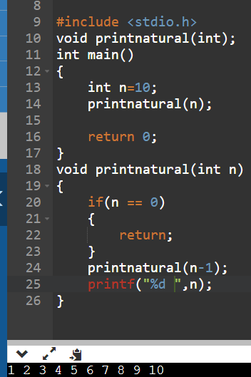

**Question – 2 Write a recursive function to print first N natural numbers in reverse order.**

**Ans.**

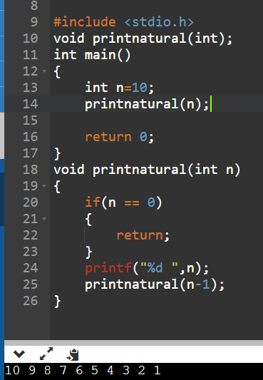

**Question – 3 Write a recursive function to print first N odd natural numbers**

**Ans.**

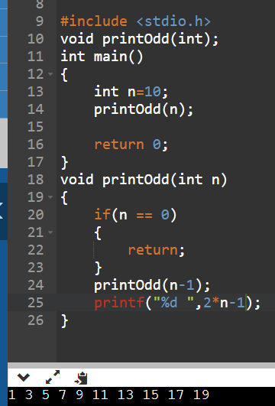

**Question – 4 Write a recursive function to print first N odd natural numbers in reverse order.**

**Ans.**

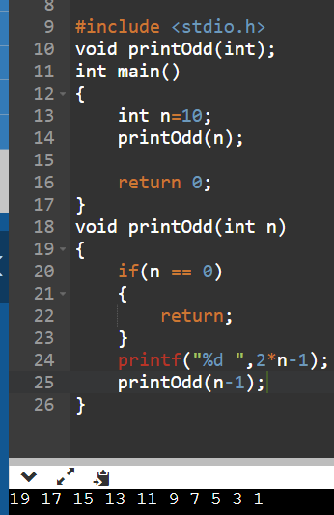

**Question – 5 Write a recursive function to print first N even natural numbers**

**Ans.**

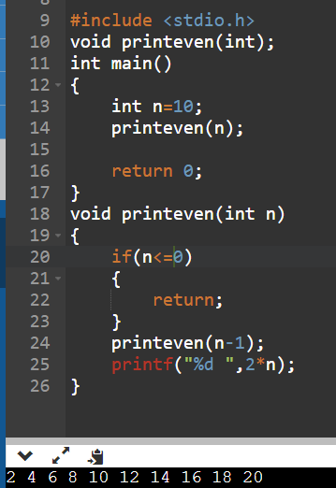

**Question – 6 Write a recursive function to print first N even natural numbers in reverse order**

**Ans.**

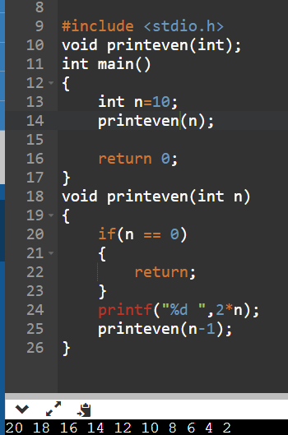

**Question – 7 Write a recursive function to print squares of first N natural numbers**

**Ans.**

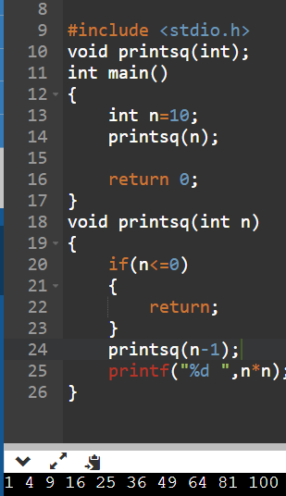

**Question – 8 Write a recursive function to print binary of a given decimal number.**

**Ans.**

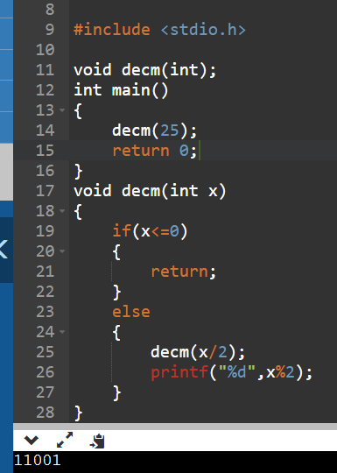

**Question – 9 Write a recursive function to print octal of a given decimal number.**

**Ans.**

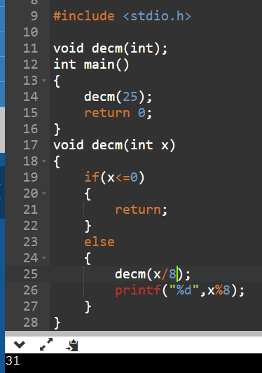

**Question -10 Write a recursive function to print reverse of a given number.**

**Ans.**

